

TEAM - Amanda, Vincent, Kang, Javier

Name of App - Cravings

Description - What are you craving? The purpose of the app is to find a specific food, and locate the restaurants that will have it on the menu.

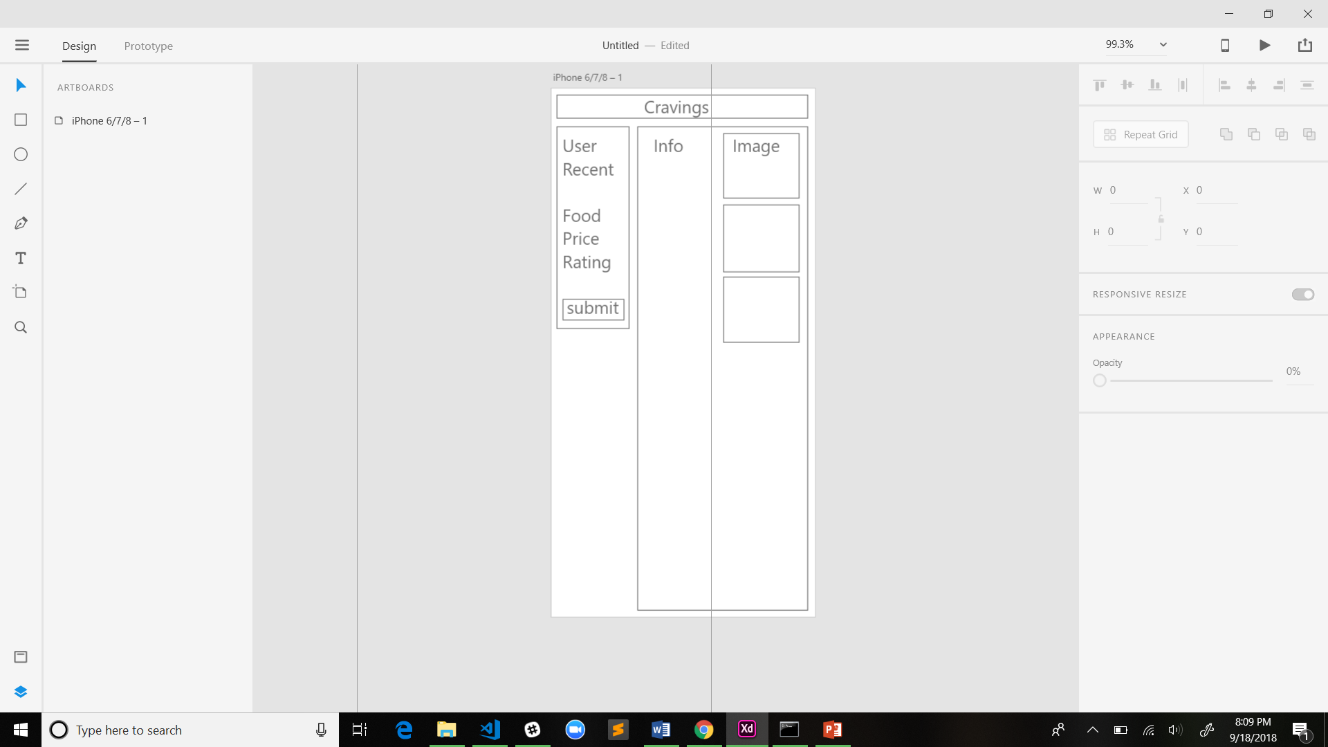

User hypothetically will have that ability to save recent searches.

Search food based on type, price and rating, restaurant.

API- doordash - Food lists, pricing, ratings

API - google maps - location purposes

API - additional api are being searched.